**Xiaoyu Wan**

**DCS 461 Database**

**Project 2 Relation Schema**

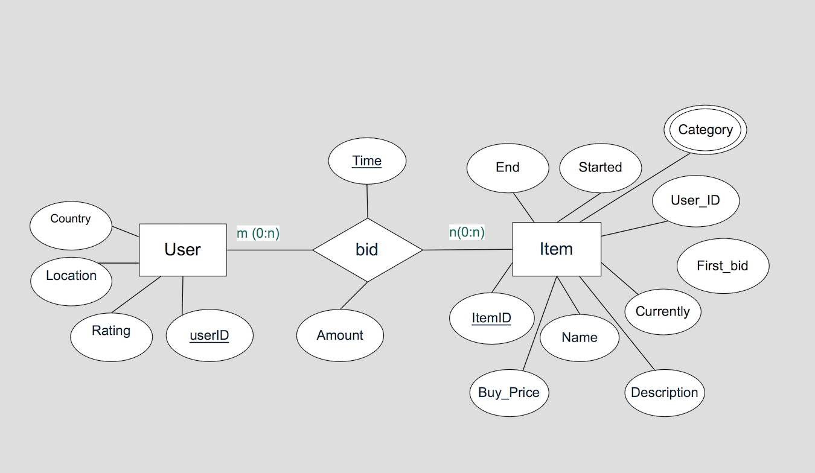

**Item**

|  |  |  |  |  |  |  |  |  |
| --- | --- | --- | --- | --- | --- | --- | --- | --- |
| itemID | name | currently | buy_price | first_bid | started | ends | userID | description |

**User**

|  |  |  |  |
| --- | --- | --- | --- |
| userID | rating | location | country |

**Category**

|  |  |
| --- | --- |
| itemID | Category |

**Bid**

|  |  |  |  |
| --- | --- | --- | --- |
| itemID | userID | time | amount |

**Item**

itemID: char(10) primary key

name: varchar (100)

currently: decimal (10,2)

buy_price: decimal (10,2)

first_bid: decimal (10,2)

started: timestamp

ends:timestamp

userID: varchar (100), foreign key

(References to userID in User relation)

Description: text

**User**

userID: varchar (100), Primary Key

rating: int

location varchar(100),

country varchar(20)

**Category:**

category varchar(100) Not Null,

PRIMARY KEY(itemID,category),

FOREIGN KEY (itemID) REFERENCES Item(itemID)

**Bid:**

itemID char(10) Not Null,Primary Key

userID varchar(100),

time timestamp, Primary Key

amount decimal(10,2),

FOREIGN KEY (itemID) REFERENCES Item(itemID)

FOREIGN KEY(userID) REFERENCES User(userID)